**Azure App Services - Web Apps**

* Introduction
* App Service - Application Types
* Deploy Web Apps
  + Deploying Web App directly from Visual Studio
  + Automate deployment from Dropbox and One Drive
  + Create, configure and deploy packages
  + Implement pre- and post-deployment actions
* App Service plans
  + Create App Service Plan
  + Migrate Web Apps between App Service plans;
  + Create a Web App within an App Service plan
* Configuring Web Apps
  + Application Settings Configuration,
  + Database Connection Strings,
  + Configuring Handlers and Virtual Directories,
* Manage App Services
  + Configure a custom domain name
  + Enable SSL for your custom domain
  + Understanding Deployment Slots and Roll back deployments;
  + App Service Protection
  + Manage Roles for an App service
* Configure Web Apps for scale and resilience
  + Horizontal and Vertical Scaling of a Web App
  + Configure auto-scale
  + Change the size of an instance
* Monitoring, Debugging and Diagnosis
  + Retrieve Diagnostics data
  + View Streaming Logs
  + Configure endpoint monitoring
  + Configuring Alerts
  + Configure diagnostics
  + Use remote debugging
  + Monitor Web App resources

**Azure App Services Introduction**

* Azure App Service is the cloud PaaS service that integrates everything you need to **quickly and easily** build web and mobile apps for **any platform** and **any device**.
* Built for developers, App Service is a **fully managed platform** with powerful capabilities such as built-in DevOps, continuous integration with Visual Studio Team Services and GitHub, staging and production support, and automatic patching.
* App Service is a platform as a service (PaaS), which means that the OS and application stack are managed for you by Azure; you only manage your application and its data.
* Azure manages OS patching on two levels, the physical servers and the guest virtual machines (VMs) that run the App Service resources. Both are updated monthly. These updates are applied automatically, in a way that guarantees the high availability SLA of Azure services.
* New stable versions of supported language runtimes (major, minor, or patch) are periodically added to App Service instances. Some updates overwrite the existing installation, while others are installed side by side with existing versions. An overwrite installation means that your app automatically runs on the updated runtime. A side-by-side installation means you must manually migrate your app to take advantage of a new runtime version.

**App Types**

App Service allows you to create the following app types from a single development experience:

1. [**Web Apps**](https://azure.microsoft.com/en-in/documentation/articles/app-service-web-overview) - Quickly create and deploy mission critical Web apps that scale with your business.
2. [**API Apps**](https://azure.microsoft.com/en-in/documentation/articles/app-service-api-apps-why-best-platform) - Easily build and consume Cloud APIs.
3. [**Logic Apps**](https://azure.microsoft.com/en-in/documentation/articles/app-service-logic-what-are-logic-apps) - Automate the access and use of data across clouds without writing code.
4. **Function Apps –** Function written by developer and executed without any dedicated hardware.

As a single integrated service, App Service makes it easy to compose the above app types into a single solution, allowing you to easily build apps that target both **web and mobile clients** using the same back-end and integrate with on premise systems as well as popular services such as Office 365 and salesforce.com.

**App Service Web Apps** is a fully managed **compute platform** that is optimized for hosting websites and web applications. This [platform-as-a-service](https://en.wikipedia.org/wiki/Platform_as_a_service) (PaaS) offering of Microsoft Azure lets you focus on your business logic while Azure takes care of the infrastructure to run and scale your apps.

The compute resources may be on shared or dedicated virtual machines (VMs), depending on the pricing tier that you choose.

Your code can be in any language or framework that is supported by [Azure App Service](https://docs.microsoft.com/en-us/azure/app-service/app-service-value-prop-what-is), such as **ASP.NET, ASP.NET Core, .NET6, Node.js, Ruby, Java, PHP, or Python**.

**Why Web Apps:**

1. Multiple languages and frameworks
2. Application templates in Azure Marketplace. Templates in the Azure Marketplace, such as WordPress, Joomla, and Drupal.
3. DevOps optimization. Continuous integration and Continuous deployment.
4. Test in production using Deployment slots
5. Global scale with high availability. Scale up or out manually or automatically.
6. Connections to SaaS platforms and on-premises data.
7. Visual Studio Integration.
8. App Service is ISO, SOC, and PCI compliant.

**Create and Deploy App Service Web Apps**

Deploying your app to App Service is a matter of deploying your code, binaries, content files, and their respective directory structure, to the **/site/wwwroot** directory in Azure.

1. **Create a Web App in Azure Portal**
   1. Login to Azure Portal, <https://portal.azure.com/>
   2. Azure Portal 🡪 More Services 🡪 Web App 🡪 + Add
   3. Select Web Apps 🡪 Create
   4. Name = "DssDemoWebApp", Subscription = "Free Trail" Resource Group="DemoRG", App Service plan/Location=Create New Plan (Name=Standard_Plan, Location=Central US, Pricing tier=S1 Standard.
   5. Application Insights=Off
   6. Create
2. **Visual Studio 🡪 Create a new ASP.NET MVC Web Application** 
   1. File 🡪 New 🡪 Project
   2. Visual C# 🡪 ASP.NET.Core Web Application, Project Name="DemoWebApp" 🡪 OK
   3. Select Template = MVC, Change Authentication = No Authentication 🡪 OK

Note: In a few seconds, Visual Studio creates the web project in the folder that you specified

1. **Deploy / Publish the project from VS.NET.**
   1. In **Solution Explorer**, right-click the project, and choose **Publish**.

The wizard opens to a publish profile that has settings for deploying the web project to the new web app. If you wanted to deploy to a different web app, you could click the **Profile** tab to create a different profile.

* 1. Choose default options and finally **click on Publish**.

The **Output** and **Azure App Service Activity** windows show what deployment actions were taken and report successful completion of the deployment.

**Deploying using Eclipse?**

<https://docs.microsoft.com/en-us/azure/developer/java/toolkit-for-eclipse/create-hello-world-web-app>

1. **Getting Publish Profile from Azure Portal and publishing from Visual Studio**

**Ideally used when developer doesn’t have direct access to Azure Subscription.**

* 1. Click **App Services**, and then click the name of your web app.
  2. In the tool bar click on **Get Publish Profile**
  3. Save the Profile locally on your disk.
  4. Go to VS.NET, Right Click on Project 🡪 Publish
  5. Select Profile Tab 🡪 **Click Import** 🡪 Provide the downloaded profile name 🡪 OK
  6. Click Publish.

Note: Profile will be saved for further use in <Project>/Properties/PublishProfiles/*.pubxml

**To gets an Azure Web App publishing profile using PowerShell:**

Get-AzWebAppPublishingProfile -ResourceGroupName "DemoRG" -Name "DemoWebApp" -Format "WebDeploy" -OutputFile "D:\outputfile.publishsettings"

1. **Publishing using FTP tools like FileZilla/Windows Explorer**
   1. Azure Portal 🡪 Click **App Services**, and then click the name of your web app.
   2. Go to Settings 🡪 select **Deployment Center**
   3. Provide FTP/deployment user name and password
   4. Save
   5. Look at Essentials Section of Selected App Service and copy FTPS hostname and user name
   6. Open **Windows Explore** and use the above hostname and credentials to connect and upload files.

Note: The User Credentials: FTP Username/Password is same for all applications in a given subscription.

Note: Although it's easy to copy your web app's files to Azure using FTP utilities, they don't automatically take care of or coordinate related deployment tasks such as deploying a database or changing connection strings. Also, many FTP tools don't compare source and destination files in order to skip copying files that haven't changed. For large Apps, always copying all files can result in long deployment times even for minor updates since all files are always copied.

**~~Automate deployment from Dropbox and One Drive~~**

~~Dropbox is not a source control system, but if you store your source code in Dropbox you can automate deployment from your Dropbox account.~~

1. ~~Create a drop box account @~~ **~~http://www.dropbox.com~~**
2. ~~Go to~~ [~~http://portal.azure.com/~~](http://portal.azure.com/)
3. ~~Select the App Service 🡪 Settings 🡪 Deployment🡪~~ **~~Deployment options~~** ~~🡪 Configure required Settings 🡪 Dropbox~~
4. ~~Authorize Azure to access your drop box~~
5. ~~Go to https://www.dropbox.com/ and go to folder Apps 🡪 Azure 🡪 Create a folder by name: <WebApp Name>~~
6. ~~Upload the files to the above folder~~
7. ~~Go to Azure Portal~~
8. ~~Select the App Service 🡪 Settings 🡪 Publishing 🡪 Deployment Source 🡪 Sync the App Service~~
9. ~~View the page in browser.~~

~~The cons of syncing with a cloud folder are:~~

* ~~No version control for rollback when failures occur.~~
* ~~No automated deployment, manual sync is required.~~

~~Note: Similar steps are required even for One Drive.~~

**ZIP Deploy:**

Zip the project and drag and drop to file explorer in the below url

[**https://dssdemo-appsrv.scm.azurewebsites.net/ZipDeployUI**](https://dssdemo-appsrv.scm.azurewebsites.net/ZipDeployUI)

**Deploying Java Web App to App Service using Maven Plug-in**

1. Download and extract Maven 3.8.1 from <https://archive.apache.org/dist/maven/maven-3/> to C:\Java
2. Search Environmental Variables and add to Path: C:\Java\apache-maven-3.8.1\bin
3. Run the following command to create a New Tomcat App

mvn archetype:generate "-DgroupId=example.demo" "-DartifactId=helloworld" "-DarchetypeArtifactId=maven-archetype-webapp" "-Dversion=1.0-SNAPSHOT"

cd helloworld

OR

Clone the Spring Boot getting started sample project

git clone <https://github.com/spring-guides/gs-spring-boot>

cd gs-spring-boot/complete

1. Run the Maven command below to configure the deployment. This command will help you to set up the App Service operating system, Java version, and Tomcat version.

**mvn com.microsoft.azure:azure-webapp-maven-plugin:2.1.0:config**

Note: You can modify the configurations for App Service directly in your pom.xml if needed.

1. Deploy the Java application to Azure with below command

**mvn package azure-webapp:deploy**

**App Service Plan**

* App Service plans represent the collection of physical resources used to host your apps.
* App Service plans define:
  + Region (West US, East US, etc.)
  + SKU (Free, Shared, Basic, Standard, Premium, Isolated) – Features.
  + Instance size (Small, Medium, Large) – Memory and Processor
  + Scale count (one, two, three instances, etc.)
* Web Apps, Mobile Apps, API Apps, or Functions, in Azure App Service all run in an App Service plan. Apps in the same subscription, region, and resource group can share an App Service plan.
* All applications assigned to an **App Service plan** share the resources defined by it allowing you to save cost when hosting multiple apps in a single App Service plan.

Note: The requested app service plan cannot be created in the current resource group because it is hosting Linux apps. Please choose a different resource group or create a new one.

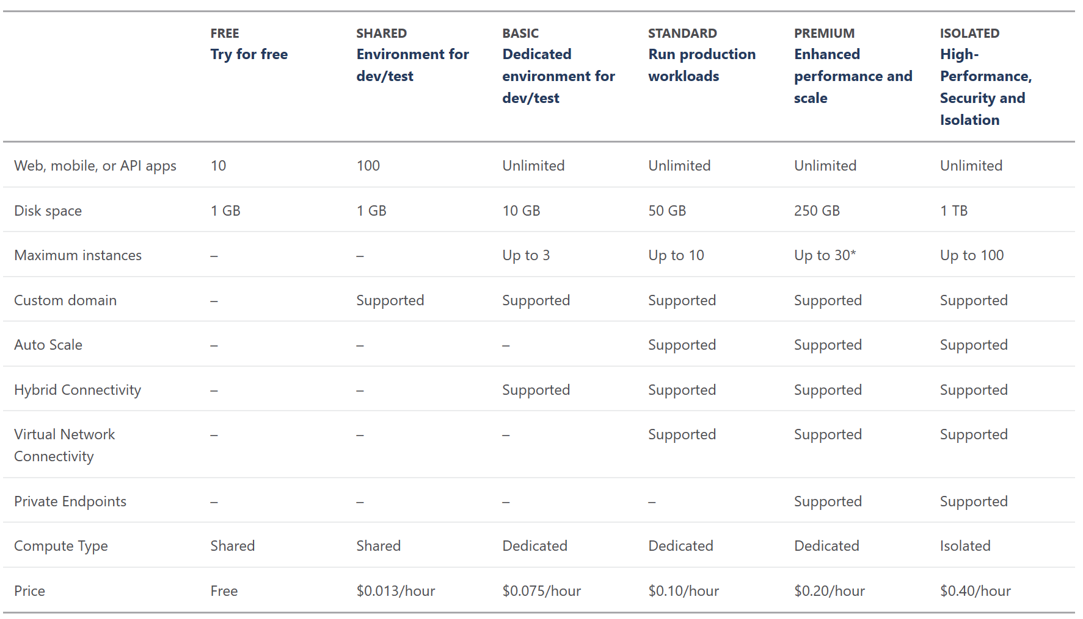

**Isolated**. This tier runs dedicated Azure VMs on **dedicated Azure Virtual Networks**, which provides network isolation on top of compute isolation to your apps. It provides the maximum scale-out capabilities.

Because a single resource group can have multiple App Service plans, you can allocate different apps to different physical resources that spans geographical regions. For example, a highly available app running in two regions includes at least two plans, one for each region, and one app associated with each plan. In such a situation, all the copies of the app are then contained in a single resource group. Having a resource group with multiple plans and multiple apps makes it easy to manage, control, and view the health of the application.

* It is recommended to isolate an app into a new App Service plan when:
* App is resource-intensive.
* App has different scaling factors from the other apps hosted in an existing plan.
* App needs resource in a different geographical region.
* You can move an app to a different App Service plan in the Azure portal. **You can move apps between plans as long as the plans are in the same resource group and geographical region.**

AS0, AS1, AS6 - AP1 (RG1/East US)

AS2 - AP2 (RG1/West US)

AS3 - AP3 (RG1/East India)

- AP4 (RG1/East US)

- AP5 (RG2/East US)

* You can create an **empty App Service plan** and then select the same while creating an App Service or you can create an App Service Plan while creating an App Service.
* If you want to move the app to a different region, one alternative is app cloning. Cloning makes a copy of your app in a new or existing App Service plan in any region. You can find **Clone App** in the **Development Tools** section of the menu. The web app must be running in the **Standard** mode in order for you to create a clone for the web app.

**Scaling a ~~Web App~~ App Service Plan**

* Whether your application needs to handle a few hundred requests per day or a few million requests per day, the Azure Web Apps scalability features provide ways for you to deliver the right level of scale in a robust, cost-effective manner.
* When you consider the scalability requirements of an application, you should look at its resource requirements **vertically** (scaling up) **horizontally** (scaling out).
* You typically choose to **scale up** when any single request demands more memory and processing power to complete, and the ***bottleneck / latency in the system is the intensive number of software objects created in the computer’s memory or the intensive algorithms and business logic that is performed.*** When you scale up a web app, you increase the resource capacity, **such as RAM and CPU cores**, of the virtual machine on which your web app is running.
* You typically **scale out** when any single request requires **less** memory and processing power to complete, but the real ***bottleneck / latency is in network communication, disk access, etc.*** *In this case, the key to completing each request more efficiently is to* ***run it in parallel*** *to other requests as each wait on external components to complete****.*** To scale out a web app, you **increase the number of virtual machine/app service instances** on which your web app is running. For the properly architected app, this means your web app can handle more load and therefore service more user requests.

If you scale an app in the Basic tier to two instances, you have 350 concurrent connections for each of the two instances. For Standard tier and above, there are no theoretical limits to web sockets, but other factors can limit the number of web sockets. For example, maximum concurrent requests allowed (defined by maxConcurrentRequestsPerCpu) are: 7,500 per small VM, 15,000 per medium VM (7,500 x 2 cores), and 75,000 per large VM (18,750 x 4 cores).

**Scale Up (Vertical Scaling) the Azure Web App:**

* The ability to scale up a web app exists only for web apps configured for Basic, Standard, or Premium pricing tiers.
* The scale settings take only seconds to apply and affect all web apps in your App Service plan. They do not require your code to be changed or your applications to be redeployed.

**To Scale Up**

1. App Services 🡪 Select App Service 🡪 Settings 🡪 **Change App Service Plan** (In App Service Plan) 🡪 Select / Create New Plan
2. Select the Pricing tier based on following options:
   1. **Number of Cores**
   2. **RAM**
   3. Storage
   4. Slots (Number of CPU Instances)
   5. Backup frequency
   6. Traffic Manager facility

**To Scale Out: (Horizontal Scaling)**

The number of Virtual Machine Instances you can scale out is limited by the pricing tier configured for your web app.

1. App Services 🡪 Select App Service 🡪 Settings 🡪 App Service Plan
2. Select Scale Out (App Service Plan) to configure settings
   1. Scale by: **Manual** - Manual setup means that the number of instances you choose won't change, even if there are changes in load.
      1. Basic = 3 Instances
      2. Standard = 10 Instances
      3. Premium P1/P2 = 20 Instances
      4. Premium P3 = 30 Instances
   2. Scale by: **CPU percentage**: Automatically scale based on CPU Percentage used. You can choose an average value you want to target.
   3. Scale by: **Schedule and Performance Rules** - Create your own set of rules. Create a schedule that adjusts your instance counts based on time and performance metrics.

**Autoscale Metrics**

|  |  |  |
| --- | --- | --- |
| **Metric** | **Metric identifier** | **Description** |
| **CPU** | CpuPercentage | The average amount of CPU time used across all instances of the plan |
| **Memory** | MemoryPercentage | The average amount of memory used across all instances of the plan |
| **Data in** | BytesReceived | The average incoming bandwidth used across all instances of the plan |
| **Data out** | BytesSent | The average outgoing bandwidth used across all instances of the plan |
| **HTTP queue** | HttpQueueLength | The average number of HTTP requests that had to sit in the queue before being fulfilled. A high or increasing HTTP queue length is a symptom of a plan under a heavy load. |
| **Disk queue** | DiskQueueLength | The average number of both read and write requests that were queued on storage. A high disk queue length is an indication of an application that might be slowing down due to excessive disk I/O. |

**Auto scale based on CPU percentage:**

* The Target range setting defines the **minimum** and **maximum** CPU percentage to target.
* As long as the CPU percentage is within this range, Autoscale will not increase or decrease the number of instances.
* When the CPU percentage exceeds the maximum CPU percentage you specify, Autoscale will add an instance. If CPU percentage continues to exceed the maximum CPU specified, then Autoscale will add another instance.

At no point will you have more than the maximum number of instances specified in the Instances setting.

* Similarly, when CPU percentage falls below the minimum CPU percentage you specify, Autoscale will remove an instance. If CPU percentage continues to all below the minimum CPU percentage specified, then Autoscale will remove another instance. At no point will you have fewer than the minimum number of instances specified in the Instances setting

**Note**: The CPU percentage is measured as an **average across all instances**. For example, if you have two instances, one of which is running at 50 percent CPU and the other of which is running at 100 percent CPU, then the CPU percentage would be 75 percent for all the instances at that point in time

**App Services Configuration**

**Azure Portal:**

App Services 🡪 Select App Service 🡪 Settings 🡪 **Configuration**

1. .NET version = .NET Core 6.0
2. Enable Debugging
3. Add Key – Value pair to the App Settings, Note that this overwrites the same key added to web.config / appSettings.json in VS.NET project and published.
4. Add Connection String if required
5. Set Default page for the web site.
6. HttpHandler mappings can be Set
7. Virtual applications and directories can be added

**ASP.NET Core:**

**appSettings.json**

"Name": {

"FirstName": "Sandeep",

"LastName": "Soni"

}

**HomeController.cs**

string name;

public HomeController(IConfiguration configuration)

{

name = configuration["Name:FirstName"];

}

public IActionResult Index()

{

ViewBag.Name = name;

return View();

}

**Index.cshtml**

<div>

@ViewBag.Name

</div>

web.config OR appSettings.json = Least Precidence

web.release.config / web.debug.config OR appSettings.json / appSettings.Development.json

Azure 🡪 App Service 🡪 Configuration 🡪 Application Settings = Highest Precidence

**Default documents:**

* Only available for **Windows** apps
* List of documents to show when navigating to a directory on the web server:
  + First matching file is used
* Alternative to building a custom module

**CORS:**

* Browser security prevents a web page from making requests to a different domain than the one that served the web page. This restriction is called the ***same-origin policy***. The same-origin policy prevents a malicious site from accessing sensitive data on another site.
* In a standard CORS implementation, the JavaScript client will send a **pre-flight request** by using an **OPTIONS** verb to assess the server's willingness to accept a cross-site request. If allowed, the JavaScript client will then issue a **cross-site HTTP request**.
* Servers can specify:
  + Allowed HTTP verbs
  + Allowed origins
  + Allowed headers

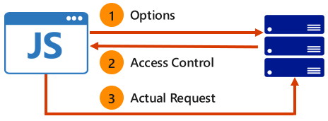

**Deployment Slots**

* A deployment slot technically is an **independent** web app with its own content, configuration, and even a unique host name. So, it functions just like any other web app.
* Each Slot is reachable from its unique URL. For example for Staging deployment slot:

*http://dssdemoapp.azurewebsites.net/*

*http://dssdemoapp-****staging****.azurewebsites.net/*

* This option is available only in **Standard** and above pricing tier.

**Benefits of Deployment Slots:**

1. You can deploy changes for your application to a **staging deployment slot** and test the changes without impacting users who are accessing the **production deployment slot**. When you are ready to move the new features into production, you can just **swap the staging and production** slots **with no downtime** (**Blue-Green Deployment**)
2. You can **swap back** to the previous deployment if you realize that the new version of your application is not working as you expected.
3. You can "**warm up**" your application in a staging slot before swapping it into the production slot, avoiding the long delays a cold start of your application may incur because of some lengthy initialization code.
4. You can do **A/B testing** with a small set of users to try out new features of your application without impacting the majority of users who are using the production slot.

Note: A/B testing (also known as [split testing](https://www.optimizely.com/split-testing/) or [bucket testing](https://www.optimizely.com/optimization-glossary/bucket-testing/)) is a method of comparing two versions of a webpage or app against each other to determine which one performs better. AB testing uses data & statistics to validate new design changes and improve your conversion rates.

1. Can be used for **Canary** Deployments.

**Slot Supports basic on Plan**

Basic = No slots support

Standard = 5 Slots

Premium = 20 Slots

## **Configuration for deployment slots**

When you clone configuration from another deployment slot, the cloned configuration is editable. Furthermore, some configuration elements will follow the content across a swap (not slot specific) while other configuration elements will stay in the same slot after a swap (slot specific).

|  |  |
| --- | --- |
| **Settings that are swapped**:   * General settings - such as framework version, 32/64-bit, Web sockets… * App settings (can be configured to stick to a slot) * Connection strings (can be configured to stick to a slot) * Handler mappings * Monitoring and diagnostic settings. * WebJobs content | **Settings that are not swapped**:   * Publishing endpoints (URL) * Custom Domain Names * SSL certificates and bindings * Scale settings * WebJobs schedulers |

**Adding a Deployment slot:**

1. App Services 🡪 Select App Service 🡪 Settings 🡪 Deployment Slots (Publishing) 🡪 Add Slot (blade)
2. Set Name and Configuration Source

Format of **Domain Name** for Deployment Slot = <WebApp>-<**DeploymentSlotName**>.azurewebsite.net

**To Swap with Production:**

1. Go to Deployment Slot Blade 🡪 Swap
2. Set Swap type, Source and Destination.

Note: Make sure that the swap source and swap target are set properly. Usually, the swap target is the production slot.

**Auto Swap?**

Auto swap streamlines Azure DevOps scenarios where you want to deploy your app continuously with zero cold starts and zero downtime for app customers.

When auto swap is enabled from a slot into production, every time you push your code changes to that slot App Service automatically swaps the app into **production after it's warmed up in the source slot**.

Select App Service 🡪 Deployment Slots 🡪 Select Slot (staging) 🡪 Configuration 🡪 Deployment Slot section, **Auto swap enabled** = On

**Route traffic between slots (Canary Deployment)**

* All traffic is normally routed to production:
  + Production slot has 100% weighting
* You can manually configure the weight of traffic between multiple slots

**Swap with Preview?**

Swap with preview breaks down a normal swap into two phases. In phase one, any slot-specific application settings and connections strings on the destination will be temporarily copied to the source slot. This allows you to test the slot with its final configuration values. From here, you may choose to either cancel phase one to revert to your normal configuration, or proceed to phase two, which would remove the temporary config changes and complete swapping the source to destination slot.

Note: It is possible only if there is atleast one slot specific application settings.

# **Configure a Custom Domain Name in Azure App Service**

**Step 1:** Reserve the domain name. There are many domain registrars to choose from eg: GoDaddy.com

**Step 2:** Create **DNS records** that map the domain to your Azure web app.

The Domain Name System (DNS) uses data records to map domain names into IP addresses. There are several types of DNS records. For web apps, you’ll create either an ***A* record** or a ***CNAME*** **record**.

1. An A **(Address)** record maps a domain name to an IP address.
2. A **CNAME (Canonical Name)** record maps a domain name to another domain name. DNS uses the second name to look up the address. Users still see the first domain name in their browser. For example, you could map contoso.com to *<yourwebapp>*.azurewebsites.net.

www.dssdemoapp.com

1. Create CName record (**www.**dssdemoapp.com => dssdemoapp.azurewebsites.net)
2. Create Txt Record (asuid.www => 6D7F5E02604A7CC6A9FD19B8022AC8DD505ED4D51ADE0AB3D37B31ED639214C4)

dssdemoapp.com

1. Create a ARecord (@ => IP of Service ) (Only if we want to map Main domain eg: dssdemoapp.com)
2. Create Txt Record (asuid => 6D7F5E02604A7CC6A9FD19B8022AC8DD505ED4D51ADE0AB3D37B31ED639214C4)

**Note:** If the IP address changes, a CNAME entry is still valid, whereas an A record must be updated. However, some domain registrars do not allow CNAME records for the root domain or for wildcard domains. In that case, you must use an A record.

**Step 3:** Add the domain name inside the Azure Portal.

1. App Services 🡪 Select App Service 🡪 Settings 🡪 **Custom domains 🡪 Add Custom Domain**
2. Use the **DOMAIN NAMES** text boxes to enter the domain names to associate with this web app.

## **Enable SSL for your custom domain**

**Step 1:** Get the Certificate for the custom domain from the Certificate Authority (Verisign)

## **Step 2: Configure Standard pricing tier:**

Enabling HTTPS for a custom domain is only available for the **basic** tier and above in Azure App Service. Use the following steps to switch your App Service plan to S2 **Standard** tier.

1. App Services 🡪 Select App Service 🡪 Settings 🡪 App Service Plan 🡪 Pricing Tier 🡪 **S1 Standard**

**Step 3: Configure SSL in your App**

1. App Services 🡪 Select App Service 🡪 Settings 🡪 **SSL Settings**
2. In the **certificates** section, click **Upload**
3. **Upload Certificate file and provide the password**
4. In the **SSL bindings** section of the **SSL Settings** tab, use the dropdowns to select the domain name to secure with SSL, and the certificate to use. You may also select whether to use [Server Name Indication](http://en.wikipedia.org/wiki/Server_Name_Indication) (SNI) or IP based SSL.

**How SSL Works:**

**https**://www.deccansoft.com =>

1. Browser goes to server and finds who is the cetificate authority (CA).

2. It will go to CA store and get client certficate of that domain.

3. All data before sending to server is encrypted using the public key in the certificate.

4. Server receives the request and decrypt the data using the private key in the certificate.

**Important Note:** Sometimes you might want a dedicated, **static IP address** for your app. To get a static inbound IP address, you need to configure an **IP-based SSL binding**.

If you don't actually need SSL functionality to secure your app, you can even upload a self-signed certificate for this binding. In an IP-based SSL binding, the certificate is bound to the IP address itself, so App Service provisions a static IP address to make it happen.

**App Service Authentication and Authorization**

Azure App Service provides built-in authentication and authorization support, so you can sign in users and access data by writing minimal or no code in your web app, RESTful API, and mobile back end, and also Azure Functions.

App Service uses federated identity, in which a third-party identity provider manages the user identities and authentication flow for you. Five identity providers are available by default:

|  |  |
| --- | --- |
| **Provider** | **Sign-in endpoint** |
| [Microsoft Account](https://docs.microsoft.com/en-us/azure/active-directory/develop/v2-overview) | /.auth/login/microsoftaccount |
| [Facebook](https://developers.facebook.com/docs/facebook-login) | /.auth/login/facebook |
| [Google](https://developers.google.com/+/web/api/rest/oauth) | /.auth/login/google |
| [Twitter](https://developer.twitter.com/en/docs/basics/authentication) | /.auth/login/twitter |

## **Authentication flow**

The authentication flow is the same for all providers, but differs depending on whether you want to sign in with the provider's SDK:

* **Without provider SDK:** The application delegates federated sign-in to App Service. This is typically the case with **browser apps**, which can present the provider's login page to the user. The server code manages the sign-in process, so it is also called **server-directed flow or server flow**. This case applies to browser apps. It also applies to native apps that sign users in using the Mobile Apps client SDK because the SDK opens a web view to sign users in with App Service authentication.
* **With provider SDK**: The application signs users in to the provider manually and then submits the authentication token to App Service for validation. This is typically the case with **browser-less apps**, which can't present the provider's sign-in page to the user. The application code manages the sign-in process, so it is also called **client-directed flow** or client flow. This case applies to REST APIs, [Azure Functions](https://docs.microsoft.com/en-us/azure/azure-functions/functions-overview), and JavaScript browser clients, as well as browser apps that need more flexibility in the sign-in process. It also applies to native mobile apps that sign users in using the provider's SDK.

|  |  |  |
| --- | --- | --- |
| **Step** | **Without provider SDK** | **With provider SDK** |
| 1. Sign user in | Redirects client to /.auth/login/<provider>. | Client code signs user in directly with provider's SDK and receives an authentication token. |
| 2. Post-authentication | Provider redirects client to /.auth/login/<provider>/**callback**. | Client code [posts token from provider](https://docs.microsoft.com/en-us/azure/app-service/app-service-authentication-how-to#validate-tokens-from-providers) to /.auth/login/<provider> for validation. |
| 3. Establish authenticated session | App Service adds authenticated cookie to response. | App Service returns its own **authentication token** to client code. |
| 4. Serve authenticated content | Client includes authentication **cookie** in subsequent requests (automatically handled by browser). | Client code presents authentication token in **X-ZUMO-AUTH** header (automatically handled by Mobile Apps client SDKs). |

**Authorization behavior**

In the Azure portal, you can configure App Service authorization with a number of behaviors.

##### **Allow all requests (default)**

Authentication and authorization are not managed by App Service (turned off).

Choose this option if you don't need authentication and authorization, or if you want to write your own authentication and authorization code.

##### **Allow only authenticated requests**

The option is **Log in with <provider>**. App Service redirects all anonymous requests to **/.auth/login/<provider>** for the provider you choose. If the anonymous request comes from a native mobile app, the returned response is an HTTP 401 Unauthorized.

With this option, you don't need to write any authentication code in your app. Finer authorization, such as role-specific authorization, can be handled by inspecting the user's claims.

##### **Allow all requests, but validate authenticated requests**

The option is **Allow Anonymous requests**. This option turns on authentication and authorization in App Service, but defers authorization decisions to your application code. For authenticated requests, App Service also passes along authentication information in the HTTP headers.

**Register your application with Facebook**

1. Navigate to <https://developers.facebook.com/>
2. If you have not already registered, click **Apps** > **Register as a Developer**, then accept the policy and follow the registration steps.
3. My Apps 🡪 Add a New App
4. Display Name = "Demo Web App", contact email = <your login> 🡪 Create App ID
5. +Add Product 🡪 Facebook Login 🡪 Set Up 🡪 Web
6. Facebook Login 🡪 Settings 🡪 Client Oauth Settings Section, **Valid OAuth redirect URIs** = [https://**dssdemoapp**.azurewebsites.net/.auth/login/facebook/callback](https://dssdemoapp.azurewebsites.net/.auth/login/facebook/callback)
7. Settings 🡪 Basics 🡪 Copy and Store Application ID and App Secret,
8. Settings 🡪 Basics
   1. Set Privacy Policy URL = <https://www.bestdotnettraining.com/pdf/PrivacyAgreement.pdf>

Terms of Service URL = <https://www.bestdotnettraining.com/pdf/TermsAndConditions.pdf>

* 1. Save Changes

1. Make App public: Switch Status from Development to Live

**Add Facebook information to your application**

1. App Service 🡪 **Settings 🡪** **Authentication**
2. App Service Authentication = On
3. **Action to take when request is not authenticated** = **Facebook**.
4. Click **Facebook**, paste in the App ID and App Secret values which you obtained previously.
5. Save.
6. Navigate to web app and note that you are redirected to Facebook to Authenticate.

Steps For Google Authentication: <https://docs.microsoft.com/en-us/azure/app-service/configure-authentication-provider-google>

Note: If required you can use ***ClaimsPrincipal.Current*** to get all claims from the Authentication Provider.

**Backup and Restore your app in Azure**

**Snapshots** automatically create periodic restore points of your app when hosted in a **Standard or Premium App** Service plan.

The Backup and Restore feature in Azure App Service lets you easily create app backups **manually** or on a **schedule**. You can restore the app to a snapshot of a previous state by overwriting the existing app or restoring to another app.

App Service can back up the following information to an Azure storage account and container that you have configured your app to use.

* App configuration
* File content
* Database connected to your app

Backups can be up to 10 GB of app and database content (max 4GB). If the backup size exceeds this limit**, you get an error**.

1. Azure Portal 🡪 App Services 🡪 Select the App Service 🡪 Settings 🡪 Backups
2. Configure the Backup
   * Backup Storage
   * Backup Schedule
   * Backup Database
3. Backup page 🡪 Click Backup Button
4. You see a progress message during the backup process.

**Configure Partial Backups**

1. Click **Advanced Tools -> Go** setting for your web app to access Kudu
2. Identify the folders that you want to exclude from your backups. For example, you want to filter out the highlighted folder and files.

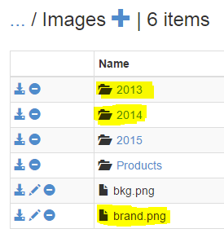

1. Create a text file called **D:\home\site\wwwroot\_backup.filter** and put the preceding list in the file. List one directory or file per line.

So the content of the file should be:

\site\wwwroot\Images\brand.png

\site\wwwroot\Images\2019

\site\wwwroot\Images\2020

If you wish, you can create the file directly using Kudu advanced tools and insert the content there.

**Integrate an App with an Azure Virtual Network**

VNet Integration enables apps to access resources in or through a VNet.

**Azure App Service has two variations on vNet Integration:**

* Multitenant systems that support the full range of pricing plans except Isolated.
* **App Service Environment (ASE),** which deploys into your VNet and supports **Isolated pricing plan** apps and **doesn't** require use of the VNet Integration feature.

VNet Integration gives your app access to resources in a VNet, but it doesn't grant inbound private access to your app from the VNet.

VNet Integration is used only to **make outbound calls** from your app into your VNet. The VNet Integration feature behaves differently when it's used with VNet in the same region and with VNet in other regions.

1. **Regional VNet Integration**: When you connect to Azure Resource Manager virtual networks **in the same region**, you must have a dedicated subnet in the VNet you're integrating with.
2. **Gateway-required VNet Integration**: When you connect to VNet in **other regions** or to a **classic virtual network** in the same region, you need an **Azure Virtual Network Gateway with Point to Site** provisioned in the target VNet.

Azure App Service 🡪 Networking 🡪 VNet Integration 🡪 Click here to configure 🡪 + Add VNet

**Using regional VNet Integration enables your app to access:**

* Resources in a VNet in the same region as your app. Private IP address of resources in VNet of can be used which programming code in App Service.
* Resources in VNets peered to the VNet your app is integrated with.
* Service endpoint secured services.
* Resources across Azure ExpressRoute connections.
* Resources in the VNet you're integrated with.
* Private endpoints.

When you use VNet Integration with VNets in the same region, you can use the following Azure networking features:

* **Network security groups (NSGs):** You can block outbound traffic with an NSG that's placed on your integration subnet. The inbound rules don't apply because you can't use VNet Integration to provide inbound access to your app.
* **Route tables (UDRs):** You can place a route table on the integration subnet to send outbound traffic where you want.

By default, your app routes only RFC1918 traffic (Private IP of VNet Resources) into your VNet. If you want to route all of your outbound traffic into your VNet, apply the app setting **WEBSITE_VNET_ROUTE_ALL** to your app.

**To configure the app setting:**

1. Go to the Configuration UI in your app portal. Select New application setting.

2. Enter **WEBSITE_VNET_ROUTE_ALL** in the Name box, and enter 1 in the Value box.

**Azure Traffic Manager**

Microsoft Azure Traffic Manager allows you to control the distribution of user traffic for service endpoints in **different datacenters around the world.**

Service endpoints supported by Traffic Manager include Azure VMs, Web Apps, and cloud services. You can also use Traffic Manager with external, non-Azure endpoints.

Traffic Manager uses the **Domain Name System (DNS)** to direct client requests to the most appropriate endpoint based on a [**traffic-routing method**](https://docs.microsoft.com/en-us/azure/traffic-manager/traffic-manager-routing-methods)and the health of the endpoints.

**There are four traffic routing methods available in Traffic Manager:**

1. **Priority:** Select 'Priority' when you want to use a primary service endpoint for all traffic, and provide backups in case the primary or the backup endpoints are unavailable.

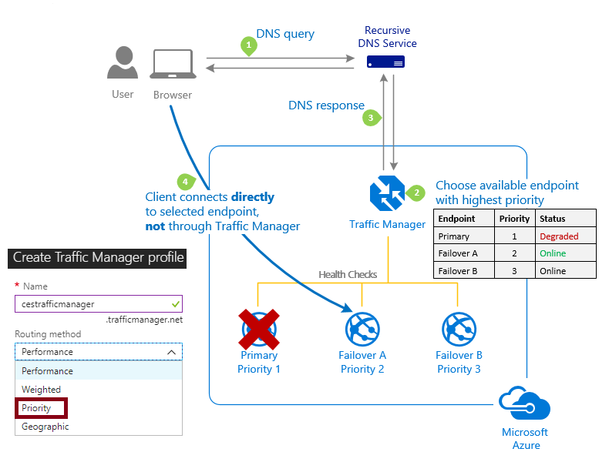

1. **Performance:** Select 'Performance' when you have endpoints in different geographic locations and you want end users to use the **"closest**" endpoint in terms of the **lowest network latency**.

The closest endpoint is not necessarily measured by geographic distance. Instead Traffic Manager determines closeness by **measuring network latency**. Traffic Manager maintains an Internet Latency Table to track the round-trip time between IP address ranges and each Azure datacenter.

With this method Traffic Manager looks up the source IP address of the incoming DNS request in the Internet Latency Table. Traffic Manager chooses an available endpoint in the Azure datacenter that has the lowest latency for that IP address range, then returns that endpoint in the DNS response.

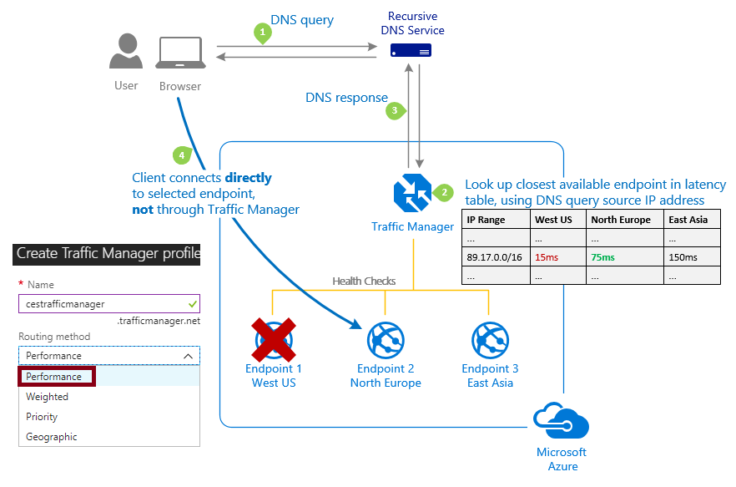

1. **Geographic:** Select 'Geographic' so that users are directed to specific endpoints (Azure, External or Nested) based on **which geographic location** their **DNS query originates** from. This empowers Traffic Manager customers to enable scenarios where knowing a user’s geographic region and routing them based on that is important. Examples include complying with data sovereignty mandates, localization of content & user experience and measuring traffic from different regions.

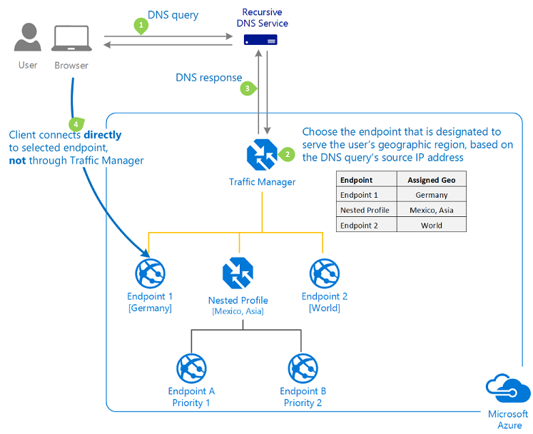

1. **Weighted:** Select 'Weighted' when you want to distribute traffic across a set of endpoints, either evenly or according to weights, which you define. The weight is an integer from 1 to 1000. The higher weignt, the higher the priority.

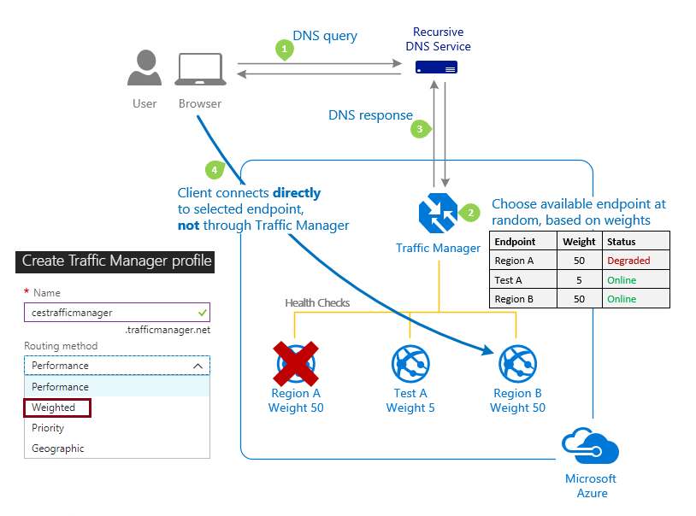

**Benefits of Traffic Manager**

1. Improve availability of critical applications.
2. Improve responsiveness for high performance applications.
3. Upgrade and perform service maintenance without downtime.
4. Combine on-premises and Cloud-based applications.
5. Distribute traffic for large, complex deployments.

## **To implement Traffic Manager**

1. Deploy the Web Apps in different Geographical locations
2. **Browse 🡪 Traffic Manager profiles 🡪 Add**
3. **Set Name=Demo, Routing Method = Weighted 🡪 Create**
4. **Go to Traffic Manger 🡪 Settings 🡪 End Points 🡪 Add**
5. **Type = Azure EndPoint, Name=WebApp1EP, Target Resource Type = App Service, Choose an App Service, Weight = 1 🡪 OK**
6. **Repeat step 5 for every Web App deployment.**

**Monitoring, Debugging and Diagnostics**

* Visual Studio, and the Azure platform collectively provide a rich set of services and tools that you can use to monitor and troubleshoot your applications.
* You can monitor your application **in real time** and interact with **near-real-time data** using the Azure portal. Or you can have the platform alert you if performance degrades or your application becomes unavailable.
* If you need to debug your app live or post-mortem, you will find the Azure Web Apps platform rich with data and analysis to get you to the root cause and resolution as fast as possible.

**Remote debugging:**

It enables you to debug your web app interactively while it is running in Azure.

**Step1:** Enable Remote Debugging

In Portal

Settings 🡪 Application Settings 🡪 Debugging 🡪

Select Remote Debugging = On,

Select Remote Visual Studio version = 2017/2019

**Step 2:** Publish the **Debug** **Build** Configuration

**Step 3:** In Server Explorer, right-click the web app and **select Attach Debugger**.

Diagnostic logs for a web app generally fall into one of two categories:

1. **Application Diagnostic Logs** are generated as a result of **logging code** you add to your application
2. **Site diagnostic logs** are generated automatically by a monitoring service configured on the web server on which your web app is running.

The types of logs that can be enabled for a web app are as follows:

1. **Application Logging**

* These are logs that are written specifically from your application code using diagnostic classes such as the **System.Diagnostics.Trace** or the **System.Diagnostics.Debug**.
* When you enable application logging, you also must specify a **log level**, which can be **Error, Warning, Information or Verbose.**

public ActionResult Index()

{

Trace.TraceError("Something is definitely wrong here.");

Trace.TraceWarning("Something could be wrong here.");

Trace.TraceInformation("Entered {0}.", this.GetType().Name);

Debug.WriteLine("This is a debug only trace message.");

return View();

}

1. **Web Server Logging**

* These are HTTP logs (that is, IIS logs) that are written by the web server on which your web app is running.
* Data in these logs contains fields defined in the W3C extended log file format defined at https://msdn.microsoft.com/library/windows/desktop/aa814385.aspx and includes things such as the **time it took** the server to process a request, **cookies** that were sent to the client or received by the client, the **client’s IP address**, and much more.

1. **Detailed error messages**

* These are HTML files written by the web server for any requests to the server that result in an HTTP status code 400 or above response. For example, if you request a resource that doesn’t exist on the server, you will get an HTTP 404 (Not Found) response.
* With detailed error messages enabled, an HTML file also will be generated containing suggested causes, possible solutions, and additional details about the request.

1. **Failed request tracing**

* These are XML files written by the web server containing a deeper level of trace information for failed requests.
* These logs contain visibility into the HTTP modules that were invoked when processing the request, time taken in each module, module tracing messages, and more.
* A new XML file is generated for each failed request and is named **fr<x>.xml** where <x> is an incrementing number. Failed request logs are intended to be viewed using a browser, and Azure Web Apps facilitates this by generating a **style sheet file** named in the directory where these files are stored.

**Enable application and site diagnostic logs:**

App Service 🡪 Settings 🡪 **App Service Logs** 🡪 Enable features as required

Log files for an Azure web app are stored on the web server’s file system hosting your web app.

1. Application logs: D:\home\LogFiles\application
2. Web server logs: D:\home\LogFiles\http\RawLogs
3. Detailed error messages: D:\home\LogFiles\DetailedErrors
4. Failed request tracing: D:\home\LogFiles\W3SVC<x>, where <x> is a random number

**Note: To Access log files stored in the web app file system either FTP can be used or using Server Explorer in VS.NET**

**OR**

Azure Portal 🡪 Select Web App 🡪 Settings 🡪 Advanced Settings (**Kudu) 🡪 Debug Console 🡪 Cmd**

**OR**

Azure Portal 🡪 Select Web App 🡪 Settings 🡪 Console (Development tools) 🡪 Change to directory as required.

**Log Stream:**

The log-streaming service in Azure Web Apps enables you to view application logs, web server logs, and detailed error messages in nearly real time.

Azure Portal 🡪 Select Web App 🡪 Settings 🡪 Log Stream

**Log streaming using Visual Studio:**

**Server Explorer 🡪 Double Click App Service 🡪 Right Click on Web App 🡪 View Streaming Logs**

In the Output window, you will see a message stating **You Are Now Connected to Log-Streaming Service**.

**Note:** You can change the logs the log-streaming service monitors by clicking the gear icon in the toolbar.

**Using Site Control Manager (Kudu) to retrieve log files**

Site Control Manager, often referred to as "Kudu", is a website extension that you can use to retrieve log files, browse the file system, edit files, delete files, view environment variables, and even capture diagnostic dump files.

To access the Site Control Manager, open your browser and navigate to

*https://<your site name>.scm.azurewebsites.net*